

ASSET VERIFICATION AND RECORDING TOOL KIT


Plot 31, Bukoto Street
P.O Box 7657, Kampala, Uganda
+256 (0) 39 2000216/0772525235
email: cpa@cpa.ug

www.cpa.com

August to September 2026

VERIFICATION DETAILS

NAME OF THE REGION: | WESTERN
SUB-REGION: | TOORO
Name of Local Government | BUNDIBUGYO
VERIFIER PARTICULARS
Full name | NABBASA SUMAYAH  NASSEJE NADIA  ZALWANGO MARIAM
Contact/ email and Telephone | 0751977570  0754884004  0708098456
Supervisor/ Sub team leader
Name | DE PAUL MBONIGABA
Contact | 0788483159
Date of submission | 06/09/2026

HEALTH CENTRES
INFORMANT INTERVIEW/DISCUSSION GUIDE (INCHARGE OR RESPONSIBLE PERSON)

Name of Health Centre: MIRAMBI HEALTH CENTRE

1a | Does the Facility have a record of all assets provided under UgIFT.  (Obtain a record and verify if it has the costs and numbers supplied | YES  Writing in inventory book
1b | If Not ask how many were supplied and when.

2 | How does this facility Maintain (repair/service/replace) the assets provided under Ugift

- For minor repairs, we do them as a facility like beds we call someone and fix them
- We have issue of 3 doors are broken and district has to send someone to repair and there are not yet sent.
- Every year we get someone from district to do repairs and maintenance of the assets and equipments.

3 | Does the facility take regular record about functionality/ or breakdown of the assets provided? | Yes

We record general expenditure but we have not yet because most of the equipments are still new and some are in use

4 | How has the UgIFT support helped in service delivery in the area, any issues, challenges and any recommendations for better program implementation.

We don’t know when they stopping to care for the facilities,
They provide nonfunctional water pump and now we are facing a problem of water at the facility.

PROCEED TO VERIFICATION AFTER THIS DISCUSSION

Health centre checklist

NAME OF LG………BUNDIBUGYO DISTRICT………………………………… NAME OF HEALTH FACILITY…………………MIRAMBI HEALTH CENTRE III……………

Equipment/ Item | Department | Asset Number | Item  Description | Life in Months | Tag Number ( engrave no.) | Date Of Purchase | Date Placed In Service | Recoverable cost | Cost | Acc Dep Cost | Net Book Value | Ytd Deprn | Equipment status | Remarks
B.P. Machine, Digital |  |  |  |  | Not graved
B.P. Machine (Aneroid wall mounted) (2) | Health |  | White in colour metal material |  | Not graved | 11/05/2023 |  |  | 679,997 |  |  |  | Good condition | In use
Autoclave 20 Liters.,Duo Operated (2) | Health |  | Silver steel with black bottom |  |  | 11/05/2023 |  |  | 3,900,000 |  |  |  | Good condition | In use
Bowl, Kick
Bowl Stand
Counting chamber Neubauer- Improved (2) | Health |  | Box |  |  | 11/05/2023 |  |  | 174,856 |  |  |  | Good condition | In store
Cupboard Steel, Lockable (6) | Health |  | Grey colour with silver locks |  |  | 11/05/2023 |  |  | 1,120,000 |  |  |  | Good condition | In use
Drip Stand (9) | Health |  | Blue with silver stand |  |  | 11/05/2023 |  |  | 280,000 |  |  |  | Good condition | In use
ESR Stand (1) | Health |  | Box |  |  | 11/05/2023 |  |  | 145,714 |  |  |  | Good condition | In store
Examination Couch(4) | Health |  | Brown in colour with metal stand |  |  | 11/05/2023 |  |  | 720,000 |  |  |  | Good condition | In use
Examination light,LED | Health |  | White in colour with a long stand |  |  | 11/05/2023 |  |  | 1,845,706 |  |  |  | Good condition | In use
 |  |  |  |  |  |  |  |  | 1,845,706
Glucometer | Health |  | Black and red  Red and black in colour |  |  | 11/05/2023 |  |  | 466,284 |  |  |  | Good condition | In use
Haemoglobin Meter, Digital | Health |  | box |  |  | 11/05/2023 |  |  | 825,710 |  |  |  | Good condition | In store
Height Meter (2) | Health |  | Silver steel with black stand |  |  | 11/05/2023 |  |  | 400,000 |  |  |  | Good condition | In use
Instrument Trolley 4 | Health |  | Stainless steel and blue color |  |  |  |  |  | 728568 |  |  |  | Good condition | In use
Microscope Binocular (1) | Health |  | Box |  |  | 11/05/2023 |  |  | 1,800,000 |  |  |  | Good condition | In store
Otoscope | Health |  | Box |  |  | 11/05/2023 |  |  | 310856 |  |  |  | Good condition | In store
Patient Screen | Health |  | Blue cloth with silver metal |  |  | 11/05/2023 |  |  | 384,000 |  |  |  | Good condition | In use
Patient Trolley (5) | Health |  | Silver steel |  |  | 11/05/2023 |  |  | 2428560 |  |  |  | Good condition | In use
Refrigerator, Basic (2) | Health |  | Blue in colour with double door, medium size |  |  | 11/05/2023 |  |  | 1,120,000 |  |  |  | Good condition | In use
Stethoscope (8) | Health |  | All in purple colour |  |  | 11/05/2023 |  |  | 194,285 |  |  |  | Good condition | Some in use and others are kept in store
Stop Watch (1) | Health |  | White in colour (box) |  |  | 11/05/2023 |  |  |  |  |  |  | Good condition | Still in store
Stretcher (2) | Health |  | Blue with silver stand |  |  | 11/05/2023 |  |  |  |  |  |  | Not handled well | Somehow tonned but in use
Stove, Gas (2) | Health |  | box |  |  | 11/05/2023 |  |  | 560,000 |  |  |  | Good condition | Well kept in store
Weighing Scale with Height Meter, Adult (2) | Health |  | Metallic stand in white colour |  |  | 11/05/2023 |  |  | 1,080,000 |  |  |  | Good condition | In use
Weighing Scale, Infant (2) | Health |  | White metallic with black stand |  |  | 11/05/2023 |  |  |  |  |  |  | Good condition | Some are spoiled already and disposed off
Weighing Scale, Toddler (1) | Health |  | Metallic blue and yellow sit |  |  | 11/05/2023 |  |  | 900000 |  |  |  | Good condition | Some are spoiled already and disposed off
Wheel Chair (4) | Health |  | Black in colour |  |  | 11/05/2023 |  |  | 640,000 |  |  |  | Not in good condition | spoiled already and disposed off
Audio Visual Equipment (1) | Health |  | Black in colour 45inches |  |  | 11/05/2023 |  |  | Not known |  |  |  | Good condition | They didn’t receive DVD player and projector
Medical Waste Bin (20) | Health |  | Steel metal material |  |  | 11/05/2023 |  |  | 369141 |  |  |  | Most of them are spoiled | In store
Wall Clock (4) | Health |  | box |  |  | 11/05/2023 |  |  | Not known |  |  |  | Good condition | In store
Diagnostic Equipment Set for MCH (3) | Health |  | box |  |  | 11/05/2023 |  |  | 632426 |  |  |  | Good condition | Kept in store
Diagnostic Equipment Set for OPD (2) | Health |  | box |  |  | 11/05/2023 |  |  | 1252212 |  |  |  | Good condition | Kept in store
Glassware Set, Laboratory, Basic (2) | Health |  | box |  |  | 11/05/2023 |  |  | 350000 |  |  |  | Good condition | Kept in store
Hollow Ware Set, Treatment (2) | Health |  | box |  |  | 11/05/2023 |  |  | 2428560 |  |  |  | Good condition | Kept in store
Instrument Set, Dressing | Health |  | Box |  |  | 11/05/2023 |  |  | 388570
Instrument Set, Basic ENT (1) | Health |  | box |  |  | 11/05/2023 |  |  | 2135000 |  |  |  | Good condition | Kept in store
Instrument Set, Suture (3) | Health |  | Box |  |  | 11/05/2023 |  |  | 437141 |  |  |  | Good condition | Kept in store
Pulse Oximeter, Hand held (1) | Health |  | box |  |  | 11/05/2023 |  |  | 2329947 |  |  |  | Good condition | Kept in store
Bed, Adult Patient with Mattress (10 | Health |  | Metallic silver steel with blue plastic board  They have a rolling boards to help move from one place to another |  |  | 11/05/2023 |  |  | Not known |  |  |  | Good condition some are dirty | All in use
Bed, Pediatric Patient, With Mattress (4) | Health |  | Silver metallic colour,  They have a balls |  |  | 11/05/2023 |  |  | 890000 |  |  |  | Good condition | Function not enough for patients
Bedside Locker (10) | Health |  | Blue doors, blue in colours |  |  | 11/05/2023 |  |  | Not known |  |  |  | Most of them are spoiled; | They claim of poor quality
Cupboard, Instrument | Health |  | grey in colours with silver locks |  |  | 11/05/2023 |  |  | Not known |  |  |  | Most of them are spoiled; | Help them to keep the equipments
Delivery Bed, Hydraulic Manual (1) | Health |  | Pink in colour with silver stand |  |  | 11/05/2023 |  |  |  |  |  |  | Good condition | Working well
Oxygen Therapy Apparatus, Mininum 45L cylinder (2) | Health |  | Blue color |  |  | 11/05/2023 |  |  | 2827158 |  |  |  | Good condition | Non functional
Resuscitator Manual, Infant, with all Mask sizes
Resuscitator Manual, Adult, with all mask sizes
Suction Apparatus, (Electric) (1) | Health |  | Box |  |  | 11/05/2023 |  |  | 2620000 |  |  |  | Good condition | In store
Nebulizer, Ultrasonic (1) | Health |  | Box |  |  | 11/05/2023 |  |  | 2,500,000 |  |  |  | Good condition | In store
Oxygen Concentrator, Duo Flow (1) | Health |  | Box |  |  | 11/05/2023 |  |  | 8,000,000 |  |  |  | Good condition | In store
Bench (4) | Health |  | Brown in colour, wooden material |  |  | 11/05/2023 |  |  |  |  |  |  | Good condition | Functional
Disinfection Buckets
Baby Cot (2) | Health |  | Stainless steel material |  |  | 11/05/2023 |  |  | 777,139 |  |  |  | Good condition | Functional
Diagnostic Equipment Set for Ward | Health |  | Stainless steel (box) |  |  | 11/05/2023 |  |  |  |  |  |  | Good condition | Non Functional
Hollow Ware Set, Ward (2) | Health |  | Box |  |  | 11/05/2023 |  |  | 3106596 |  |  |  | Good condition | In in use
Instrument Set, Delivery (5) | Health |  | Box |  |  | 11/05/2023 |  |  |  |  |  |  | Good condition | Functional
Instrument Set, Stitch Removing (5) | Health |  | Box |  |  | 11/05/2023 |  |  | 450,000 |  |  |  | Good condition | In store
MVA Kit (5) | Health |  | Box |  |  | 11/05/2023 |  |  | 730,000 |  |  |  | Good condition | Nonfunctional in store
Stool, Laboratory (3) | Health |  | Black with rolling balls |  |  | 11/05/2023 |  |  |  |  |  |  | Good condition | Some don’t have rolling balls
Penguin Sucker (3) | Health |  | Silcon material |  |  | 11/05/2023 |  |  | 32094 |  |  |  | Good condition | Some are still in store; they are using 1
Fetoscope, Dopplar (2) | Health |  | Wooden brown in colour |  |  | 11/05/2023 |  |  | 24,286 |  |  |  | Good condition | Both are used; they bought them selves of good condition
Bubble CPAP | ._ | _ | _ | _ | _ | _ | _ | _ | _ | _ | _ | _ | _ | _
Centrifuge (Electric) (1) | Health |  | box |  |  | 11/05/2023 |  |  |  |  |  |  | Good condition | Non functional
Kangaroo Mother Care Chair (1) | Health |  | Blue colour with brown handles |  |  | 11/05/2023 |  |  | 2,800,000 |  |  |  | Good condition | In use
Radiant Infant Warmer
Haemoglobin Meter, Sahli (2) | Health |  | White and red in colour |  |  | 11/05/2023 |  |  |  |  |  |  | Good condition | Well kept
Delivery Bed (1) | Health |  | Black in colour |  |  | 11/05/2023 |  |  | 3360000 |  |  |  | Good condition | Non functional
Examination light
Instrument set, ENT Basic for HCIII | Health |  | box |  |  | 11/05/2023 |  |  | 138,754 |  |  |  | Good condition | In store
Bag Valve mask (Ambu Bag), Neonatal (15) | Health |  | box |  |  | 11/05/2023 |  |  |  |  |  |  | Good condition | Some are in use and some In store
Incubator
Office Chair (2) | Health |  | Black in colour swinging |  |  | 11/05/2023 |  |  | 606,881 |  |  |  | Good condition | Well maintained
Desk (2) | Health |  | light brown wooden material |  |  | 11/05/2023 |  |  | 138,754 |  |  |  | Good condition | Looking good
 |  |  | Grey in colour metallic material
Filing Cabinet (6) | Health |  | box |  |  | 11/05/2023 |  |  | 668, 133 |  |  |  | Most of the cabins are working | They are claim that the quality was not good
Non Residential Buildings (2) | Health |  | Main building  Toilet |  |  | 11/05/2023 |  |  |  |  |  |  | Well built with separate face | Good condition with security
Residential Buildings (1) | Health |  | Nurse quarters |  |  | 11/05/2023 |  |  |  |  |  |  | Well finished; two units for nurses | Well built

SCHOOL VERIFICATION CHECKLIST

SCHOOL INTERVIEW/DISCUSSION GUIDE

Name of school: ST. PAUL NYABWEYA SEED SCHOOL (KASENDA SEED SCHOOL)

1a | Does the Facility have a record of all assets provided under UgIFT.  (Obtain a record and verify if it has the costs and numbers supplied | YES  We have inventory book
1b | If Not ask how many were supplied and when.

2 | How does this facility Maintain (repair/service/replace) the assets provided under Ugift

We do our maintenance from school funds or grants.

3 | Does the facility take regular record about functionality/ or breakdown of the assets provided?  Nonfunctional/ working, and reasons for non-functionality. | YES

We record what is needed to maintain and when it done, we record the costs in other expenses

4 | How has the UgIFT support helped in service delivery in the area, any issues, challenges and any recommendations for better program implementation.

The school serve three sub-counties, this help to increase in service delivery UgIFT help to increase the number of students and this year, we have 110 candidates; this boosted the education services in area.

Challenges
- We don’t have power led to insecurity during night. The solar provided is becoming weak and its nolonger to do a good job.
- As a headteacher, I face a challenge of transportation the facility is too far from district area. This make my work difficult mostly in rain season.
- Wild animals due to the fact that we don’t have a fence at school and we are near the game park, most of the animals cross through the school; sometimes they district students attention and school properties.

Recommendations
We look forward to UgIFT to help with a fence
- To install electricity
- To provide security

PROCEED TO VERIFICATION AFTER THIS DISCUSSION

SCHOOL FURNITURE
(School Desks, Office chairs, Laboratory stools, Book shelves)

Name of LG: KABALORE DISTRICT Name of SCHOOL: ST PAUL NYABWEYA SEEDS SCHOOL

Equipment/ Item | Department | Asset Number | Item  Description | Life in Months | Tag Number ( engrave no.) | Date Of Pur | Date Placed In Service | Recoverable cost | Cost | Acc Dep Cost | Net Book Value | Ytd Deprn | Equipment status | Remarks
SCHOOL DESKS | Education |  | Wooded desk in brown color steel stands |  | ST. PNSS F/Y/21/22 |  |  |  |  |  |  |  | 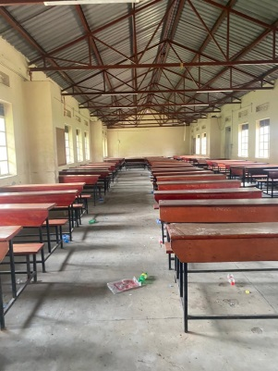
OFFICE CHAIRS | Education |  | Single seat wooden brown |  | ST. PNSS F/Y/21/22 |  |  |  |  |  |  |  | 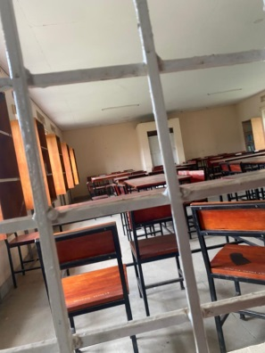
LABORATORY STOOL | Education |  | Round shaped stool with wood and steel material |  | ST. PNSS F/Y/21/22 |  |  |  |  |  |  |  | We couldn’t access the laboratory because the person with the key was not around
BOOK SHELVES | Education |  | Built in shelves in every class room ,laboratory and library |  | ST. PNSS F/Y/21/22 |  |  |  |  |  |  |  | All classrooms were closed
PIN BOARDS | Education |  | Wall hanging pin boards brown in colour in different sizes |  | ST. PNSS F/Y/21/22 |  |  |  |  |  |  |  | 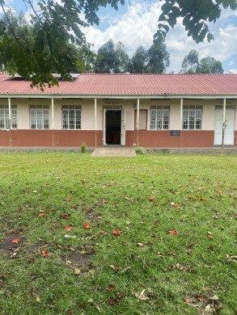
TABLES |  |  |  |  | ST. PNSS F/Y/21/22 |  |  |  |  |  |  |  | 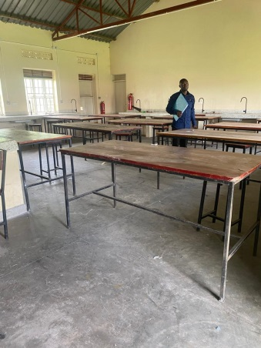
DESK TOP COMPUTER (28) | EDUCATION |  | Dell type black in colour |  | From PNSS/EQ/01/22 to From ST. PNSS/EQ/29/22 |  |  |  |  |  |  |  | 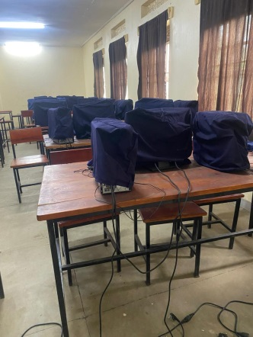
PROJECT (01) | EDUCATION |  | WHITE IN COLOUR EPSON TYPE |  | PNSS/EQ/30/22 |  |  |  |  |  |  |  | 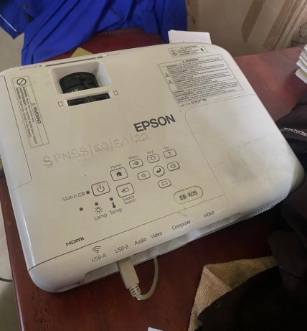
SERVER PROCESSOR | EDUCATION |  |  |  | NOT ENGRAVED
MULTIPURPOSE PRINTER (1) | EDUCATION |  | WHITE IN COLOUR |  | NOT ENGRAVED
CCTV CAMERA (1) | EDUCATION |  | WHITE IN COLOUR |  | NOT ENGRAVED
AIR CONDITIONER | EDUCATION |  | WHITE IN COLOUR |  | NOT ENGRAVED
UPS (28) |  |  | BLACK IN COLOUR |  | FROM SPNSS/EQ/001/22 TO SPNSS/EQ/028/22
NON RESIDENTIAL BUILDINGS | EDUCATION |  | 3 FINISHED BLOCKS EACH BLOCK CONTAINS 2 UNIT FOR CLASSROOMS
 |  |  | MAIN BLOCK
 |  |  | SCIENCE LABORATORY FOR BOTH PHYSICS AND BIOLOGY LABORATORY BLOCK
 |  |  | COMPUTER LAB/LIBRARY BLOCK
 |  |  | MULTIPURPOSE HALL / BUILDING
 |  |  | STAFF BLOCK
RESIDENTIAL BUILDINGS | EDUCATION |  | 3 BLOCKS EACH BLOCK HAS 2 UNITS; UNIT HAS 2 BEDIROOMS WITH A SITING ROOM AND A STORE
KITCHEN | EDUCATION |  | 3 KITCHENS EACH HAS 2 UNITS WITH CUMMINS
PIT LATRINES |  |  | 6 PIT LATRINES; 1 FOR GIRLS, 1 FOR BOYS, 1 FOR STAFF AND 3 AT STAFF QUARTERS

ICT ITEMS TO VERIFY
(Desktop Computer, Server Processor, Network Switch 24 Port, Multipurpose Printer, UPS, Projector, Air Conditioners, Server, CCTV Camera)

Name of LG…………………………………………………………………………… Name of SCHOOL………………………….………………………………………

Equipment/ Item | Department | Asset Number | Item  Description | Life in Months | Tag Number ( engrave no.) | Date Of Pur | Date Placed In Service | Recoverable cost | Cost | Acc Dep Cost | Net Book Value | Ytd Deprn | Equipment status | Remarks
DESK TOP COMPUTER (28) | EDUCATION |  | Dell type black in colour |  | From PNSS/EQ/01/22 to From ST. PNSS/EQ/29/22
PROJECT (01) | EDUCATION |  | WHITE IN COLOUR EPSON TYPE |  | PNSS/EQ/30/22
SERVER PROCESSOR | EDUCATION |  |  |  | NOT ENGRAVED
MULTIPURPOSE PRINTER (1) | EDUCATION |  | WHITE IN COLOUR |  | NOT ENGRAVED
CCTV CAMERA (1) | EDUCATION |  | WHITE IN COLOUR |  | NOT ENGRAVED
AIR CONDITIONER | EDUCATION |  | WHITE IN COLOUR |  | NOT ENGRAVED
UPS (28) |  |  | BLACK IN COLOUR |  | FROM SPNSS/EQ/001/22 TO SPNSS/EQ/028/22

BUILDINGS TO VERIFY
(Non- Residential and Residential, Kitchen, Toilets/Pit latrine Water tanks, Fences etc.)

Name of LG…………………………………………………………………………… Name of SCHOOL………………………….………………………………………

Equipment/ Item | Department | Asset Number | Item  Description | Life in Months | Tag Number ( engrave no.) | Date Of Pur | Date Placed In Service | Recoverable cost | Cost | Acc Dep Cost | Net Book Value | Ytd Deprn | Equipment status | Remarks
NON RESIDENTIAL BUILDINGS | EDUCATION |  | 3 FINISHED BLOCKS EACH BLOCK CONTAINS 2 UNIT FOR CLASSROOMS
 |  |  | MAIN BLOCK
 |  |  | SCIENCE LABORATORY FOR BOTH PHYSICS AND BIOLOGY LABORATORY BLOCK
 |  |  | COMPUTER LAB/LIBRARY BLOCK
 |  |  | MULTIPURPOSE HALL / BUILDING
 |  |  | STAFF BLOCK
RESIDENTIAL BUILDINGS | EDUCATION |  | 3 BLOCKS EACH BLOCK HAS 2 UNITS; UNIT HAS 2 BEDIROOMS WITH A SITING ROOM AND A STORE
KITCHEN | EDUCATION |  | 3 KITCHENS EACH HAS 2 UNITS WITH CUMMINS
PIT LATRINES |  |  | 6 PIT LATRINES; 1 FOR GIRLS, 1 FOR BOYS, 1 FOR STAFF AND 3 AT STAFF QUARTERS

